

Object Oriented Programming (OOP)
Object Oriented Programming (OOP) is a programming approach that focuses on objects rather than functions.
An object represents a real-world entity such as a student, car, or employee.
OOP helps in organizing complex programs into small, manageable parts.
It improves code reusability, security, and maintainability.
Languages that support OOP include C++, Java, Python, and C#.

Basic Concepts of OOP

a) Class
A class is a blueprint or template used to create objects.
It defines data members and member functions.

It contains:

Data members (variables)
Data members are variables defined inside a class that store data related to an object.
Member functions (methods)
Member functions are functions declared inside a class that operate on the data members of that class

General Syntax:
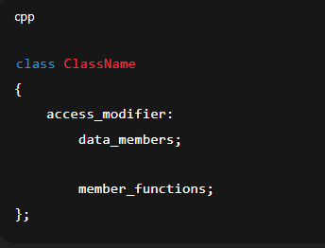

b) Object

An object is an instance of a class.
It represents a real-world entity and uses class features.
General Syntax:
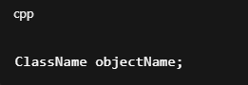

Objects access class members using the dot (.) operator.
Multiple objects can be created from the same class.
Each object has its own copy of data members.
General syntax:(to access member)
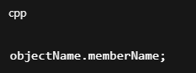

Example:
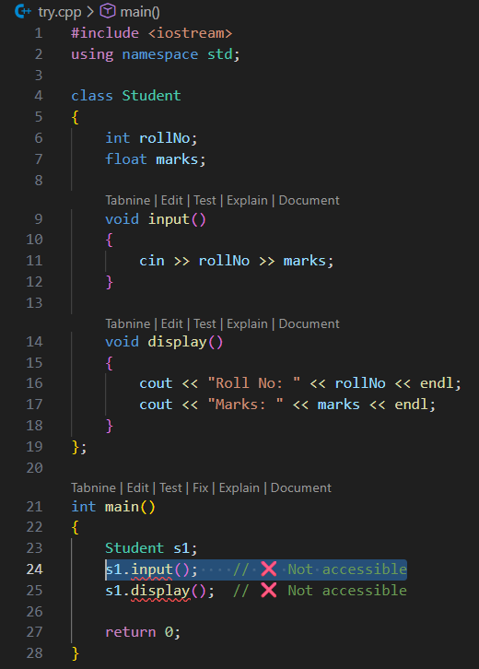

Sweet error:
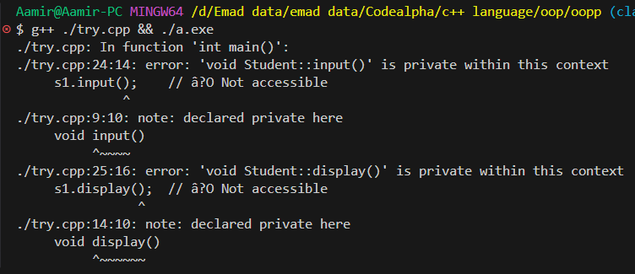

Explanation of this error:
This error occurs because class members are private by default when no access modifier is used, so they cannot be accessed outside the class.

Access Modifiers
- Access modifiers control the visibility and accessibility of class members.
- They define where data members and member functions can be accessed from.
- Access modifiers are used to protect data and implement encapsulation.
- In C++, there are three access modifiers.
Access modifiers are keywords that control the accessibility of class members in a program.

Types of Access Modifiers in C++

1. Public
- Members are accessible from anywhere in the program.
- They can be accessed using an object of the class.
- Commonly used for functions that interact with users.
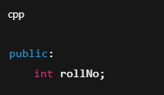

2. Private
- Members are accessible only inside the class.
- This is the default access modifier in a class.
- Used to protect sensitive data.
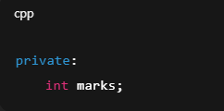

3. Protected
- Members are accessible inside the class and in derived (child) classes.
- Not accessible directly through objects.


Example:
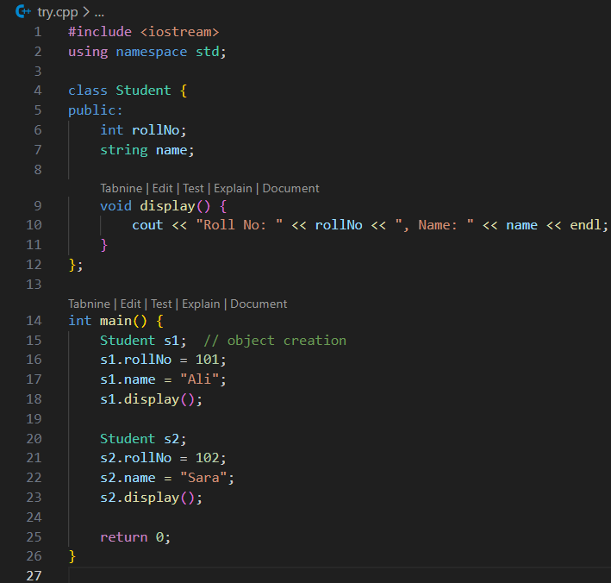

Result:
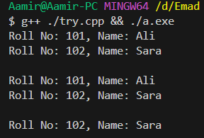

Encapsulation:
Encapsulation is the concept of binding data (variables) and functions (methods) together into a single unit called a class and restricting direct access to some of the class members to protect data.

How it works:
- Private members → store the actual data, hidden from outside.
- Public members → provide controlled access to the private data through functions (like setters and getters).

Example:
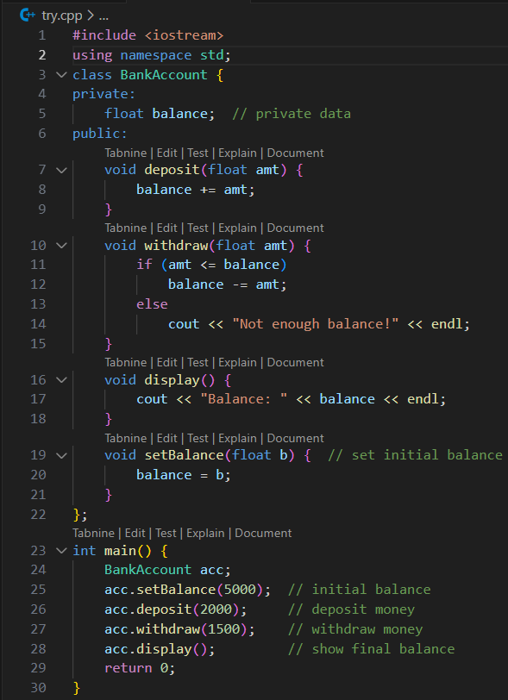

Constructors in C++
A constructor is a special member function of a class that is automatically called when an object is created.
It is used to initialize data members of the object.

Key Points
- Name: Same as the class name.
- No return type (not even void).
- Automatically executed when an object is created.
- Can have parameters (Parameterized constructor) or no parameters (Default constructor).
- Helps in initializing objects easily.
Genreal Syntax
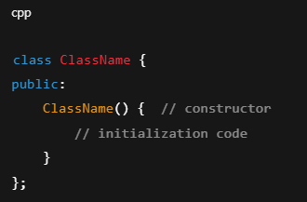

Types of Constructors in C++
Constructors in C++ are special member functions used to initialize objects.

Default Constructor
• A constructor without parameters.
• Automatically initializes data members with default values.
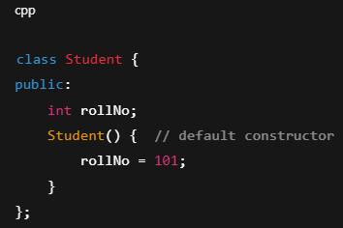

2. Parameterized Constructor

• A constructor with parameters.
• Used to initialize objects with specific values at the time of creation.

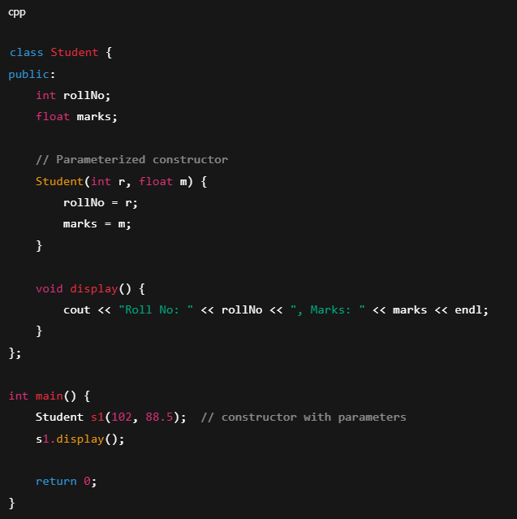

Copy Constructor
• A constructor that creates a new object as a copy of an existing object.
• Syntax: ClassName(const ClassName &obj)
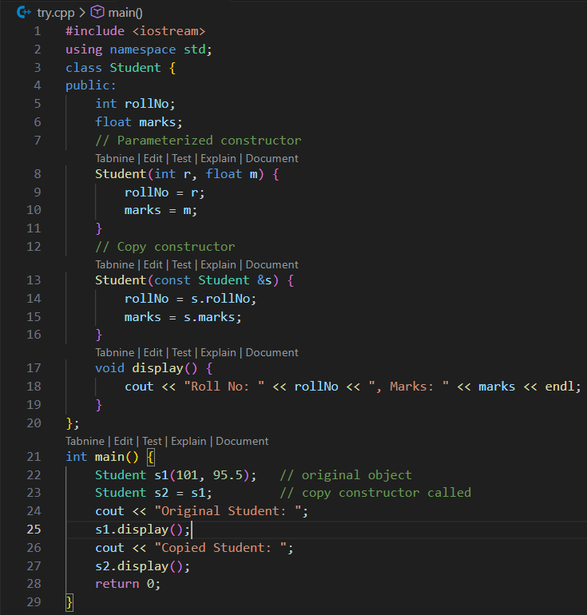

Destructor in C++
A destructor is a special member function of a class that is automatically called when an object goes out of scope or is destroyed.
It is used to release resources like memory, file handles, or network connections.

Key Points
- Same name as the class but preceded by a tilde (~).
- No return type (not even void).
- No parameters.
- Automatically called when an object is destroyed:
  - At the end of main()
  - When a local object goes out of scope
  - When a dynamically allocated object is deleted using delete
- Usually used to clean up resources (memory, files, database connections).
- Each object has its own destructor.
A destructor is a special function with a tilde (~) before the class name, automatically called when an object is destroyed to release resources.

Genral syntax:
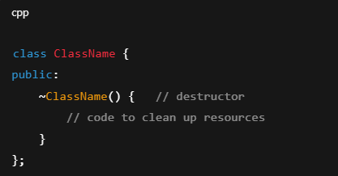

Example:
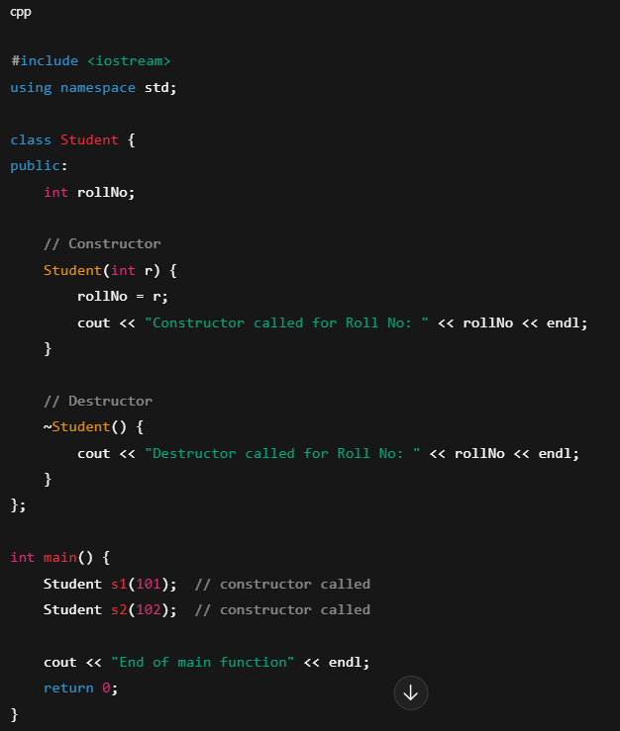

Result
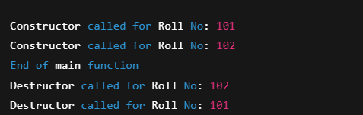

Inheritance in C++
Inheritance is an OOP concept in which one class acquires the properties and behavior (data members and member functions) of another class.
- The class that gives properties is called the Base (Parent) class
- The class that receives properties is called the Derived (Child) class
Inheritance is the mechanism by which one class acquires the properties and behaviors of another class.

Why Inheritance is Used
- Code reusability
- Saves time and reduces repetition
- Makes programs easier to maintain
- Represents real-world relationships (IS-A relationship)

General syntax
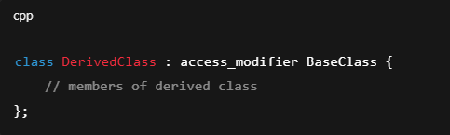

Example:
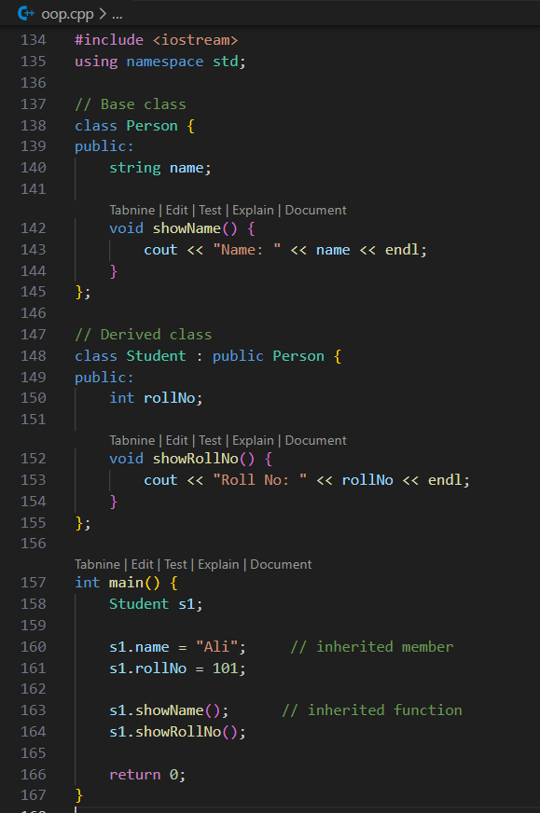

Result:
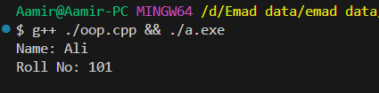

Mode of inheritance:
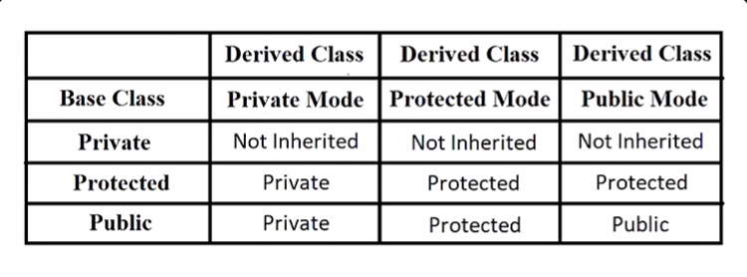

Types of Inheritance
- Single Inheritance
  - One base class → one derived class
- Multilevel Inheritance
  - Class derived from another derived class
- Multiple Inheritance
  - One class inherits from more than one base class





